Project Description: A program that connects students with mentors who can provide guidance and support in their academic and personal lives.

Classes:

- User: Represents a user of the program. Has attributes like "name" and "email". Has methods like "setPassword" and "getPassword".

- Student: Represents a student who is using the program. Inherits from "User". Has additional attributes like "major" and "graduationDate". Has methods like "setGoals" and "getGoals".

- Mentor: Represents a mentor who is providing guidance to students. Inherits from "User". Has additional attributes like "industry" and "yearsOfExperience". Has methods like "setAvailability" and "getAvailability".

- Session: Represents a mentoring session between a student and mentor. Has attributes like "date" and "notes". Has methods like "getDate" and "getNotes".

- Program: Represents the mentoring program. Has attributes like "students" and "mentors". Has methods like "addStudent" and "addMentor".

UML Class Diagram:

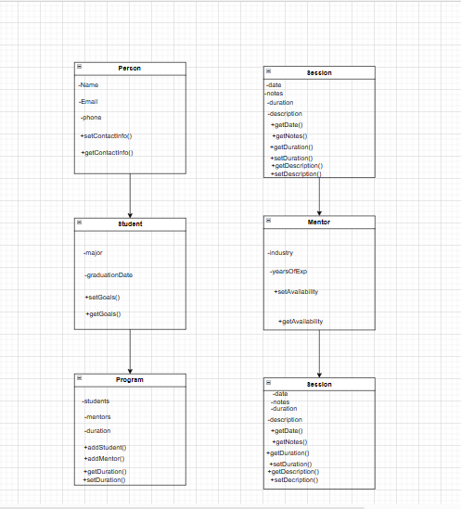

In this unique diagram, the "User" class represents a user of the program, with attributes like "name" and "email", and methods like "setPassword" and "getPassword". The "Student" class inherits from "User" and represents a student using the program, with additional attributes like "major" and "graduationDate", and methods like "setGoals" and "getGoals". The "Mentor" class also inherits from "User" and represents a mentor using the program, with additional attributes like "industry" and "yearsOfExperience", and methods like "setAvailability" and "getAvailability".

The "Session" class represents a mentoring session between a student and mentor, with attributes like "date" and "notes", and methods like "getDate" and "getNotes". The "Program" class represents the mentoring program itself, with attributes like "students" and "mentors" and methods like "addStudent" and "addMentor".

The relationships between the classes are shown in the diagram. Both "Student" and "Mentor" inherit from "User" and have a "Session" association. The "Program" has many "Students" and many "Mentors", and can facilitate many "Sessions".